1. What is useEffect?
Simple language mein:
useEffect Hook ka use React component ke andar side effects handle karne ke liye hota hai.
Side effects ka matlab hai aisa kaam jo component ki UI calculate karne ke alawa kisi external system ke saath interact karta hai.
Examples:
- Backend se API data fetch karna.
- Timer set karna.
- Event listeners add/remove karna.
- WebSocket connection manage karna.
- Browser ke saath synchronize karna.
2. useEffect ki zarurat kyun hai?
Maan lo tum ek React website bana rahe ho jahan users ki list backend se aati hai.
Tum chahte ho ki component screen par aane ke baad backend se data fetch ho aur users screen par display hon.
useEffect ke bina agar tum API call directly component ke body mein likh do, to har re-render par API call dobara ho sakti hai.
useEffect humein define karne deta hai ki effect kab run hona chahiye, based on its dependencies.
3. Syntax
import { useEffect } from "react";

useEffect(() => {
// Side effect logic

return () => {
// Optional cleanup
};
}, [dependencies]);
Iske teen parts hain:
- Effect function: kya kaam karna hai.
- Dependency array: kin values ke change hone par effect dobara run karna hai.
- Cleanup function: purane effect ke resources clean karne ke liye, jab zarurat ho.
4. Dependency array ke 3 important cases
Case 1
Empty dependency array []
useEffect(() => {
console.log("Effect ran");
}, []);
Component mount hone par effect run hota hai. Development mein Strict Mode ke kaaran initial effect extra setup/cleanup cycle se bhi guzar sakta hai.
Case 2
Dependency array mein value
useEffect(() => {
console.log("Search changed");
}, [search]);
Initial mount par aur jab search ki value change hoti hai, effect run hota hai.
Case 3
Dependency array omit karna
useEffect(() => {
console.log("Effect ran");
});
Har render ke baad effect run hota hai. Agar effect state update karta rahe, to infinite re-render loop ho sakta hai.

3 VARIATIONS
- IT WILL RUN ON EVERY RENDER
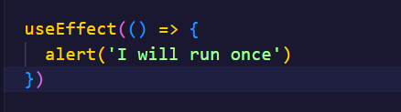
- It runs on first render
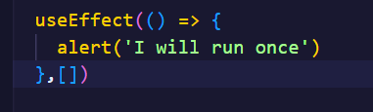
- It runs on specific counts
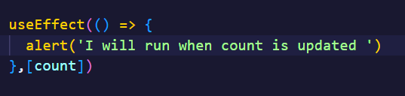
4.Multiple dependencies
